### **Multi-Omics Sequencing: Light and Electromagnetic Radiation Toward a New Frontier**
**Multi-omics sequencing** refers to the integration and simultaneous analysis of multiple molecular data layers ("omics") from the same organism or biological system, using high-throughput sequencing technologies that leverage data from different levels.
#### **Detailed Definition:**
It combines diverse omics data types, such as:
- **Genomics** (DNA sequence),
- **Transcriptomics** (RNA and gene expression),
- **Epigenomics** (chemical DNA modifications, e.g., methylation),
- **Proteomics** (proteins),
- **Metabolomics** (metabolites),
- **Microbiomics** (associated microbiota).
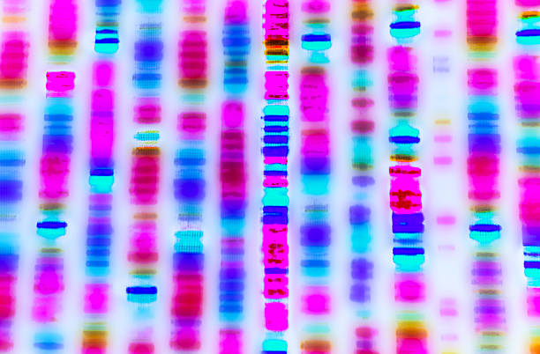

Currently, there are no high-level intervention interfaces to organize these interactions for solving biological and medical problems with their corresponding frameworks.

### **Biological Systems and Electromagnetic Energy**
Biological systems, including humans, represent phenomena of increasing complexity. For example, **ontogeny**—the process from a single cell (zygote or egg) to supracellular complexity—involves self-organization driven by interactions between living material, resulting in multicellular complexity. This process culminates in a human being that grows and develops throughout life.
A current frontier is understanding the **genetic velocities** of cell lines based on their physiological functions. This would reveal spatiotemporal variations in genetic dynamics, where electromagnetic energy (e.g., from metabolic processes) interacts with circadian rhythms. Mitochondria, for instance, package electromagnetic radiation into ATP during cellular respiration, linking energy to intrinsic biological time.
### **Beyond Classical Physics: Light as a Structuring Force**
This framework transcends classical models. Light—as an electromagnetic wave or quantum photon—acts as a **structuring variable** for biological beings and consciousness. It serves as an internal and external integrator, a "catalyst of meaning" in biological and technological systems.
Relativity Theory suggests that subsystems within a biological system interact with this energy, defining **genetic velocities**. The key is not light itself but how systems (body, mind, environment) perceive and respond to it. This could unveil an **energetic language**, forming a new frontier in multi-omics sequencing. Such principles might even guide the development of **embodied AI**—autonomous systems with human-like attributes for transformative societal benefits.
____________________________________________________________________________
### **Key Highlights**
1. **Holistic Approach:**
- Links multi-omics to fundamental processes (ontogeny, circadian rhythms) and electromagnetic energy, proposing an underlying **energetic language**.
2. **Scientific Frontiers:**
- Challenges like measuring **genetic velocities** (mutation rates? dynamic gene expression?) could revolutionize personalized medicine.
- Light as a **catalytic signal** aligns with emerging research on biophotons and cellular communication.
3. **Philosophical/Tech Implications:**
- Electromagnetic energy may structure consciousness (echoing theories by **Karl Pribram** or **Rupert Sheldrake**).
- **Embodied AI** inspired by these principles hints at biotechnological singularity.
_____________________________________________________________________________
### **Critical Reflections**
- **Science vs. Speculation:** Concepts like "energetic language" lack empirical evidence but inspire hypotheses.
- **Intervention Interfaces:** Could **nanotechnology** or **optogenetics** bridge this gap?
- **Relativity in Biology:** The link between genetic velocities and relativity needs mathematical modeling.
### **Conclusion**
This visionary document merges biology, physics, and philosophy to redefine multi-omics. While speculative, it could seed interdisciplinary research in **quantum medicine** or **complex systems biology**.
_______________________________________________________________________
#### **Glossary of Key Terms**
1. **Genetic Velocities**
- Temporal dynamics of genetic/epigenetic processes (e.g., mutation rates, gene expression speed).
- *Example:* Cancer cells may exhibit altered velocities vs. healthy cells.
2. **Energetic Language**
- Theoretical information transmission via electromagnetic signals (e.g., biophotons) or rhythmic energy patterns.
- *Analog:* Cells "communicate" through light/energy pulses, not just chemicals.
3. **Embodied AI**
- AI physically integrated into biological/robotic systems to interpret energetic signals (e.g., light) and emulate human processes.
- *Futuristic example:* A robot repairing tissues using "energetic language."
_________________________________________________________________________

